**Task 1:**

1. Install Jupyter notebook and run the first program and share the screenshot of the output.

LINK

Ans: http://localhost:8888/notebooks/Untitled2.ipynb?kernel_name=python3

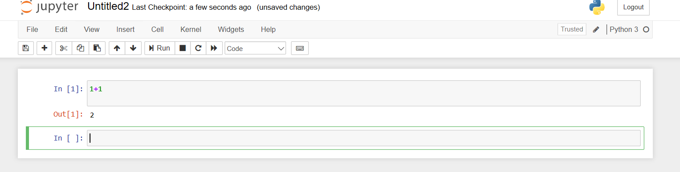

2.Write a program which will find all such numbers which are divisible by 7 but are not a multiple of 5, between 2000 and 3200 (both included). The numbers obtained should be printed in a comma-separated sequence on a single line.

Ans.n=[]

for i in range(2000,3201):

if i%7==0 and i%5!=0:

n.append(i)

print(n)

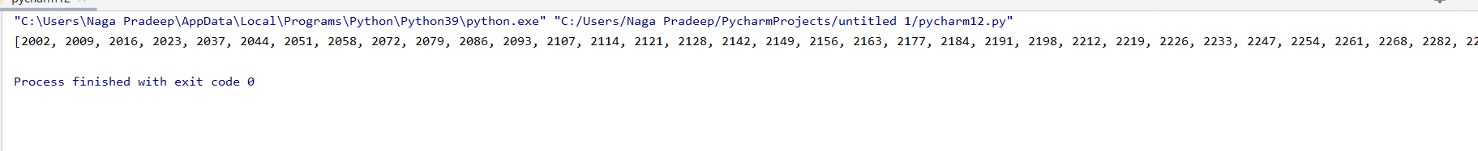

3.Write a Python program to accept the user's first and last name and then getting them printed in the the reverse order with a space between first name and last name.

Ans.firstname=input("Enter the firstname")

lastname=input("Enter the lastname")

print(lastname,firstname)

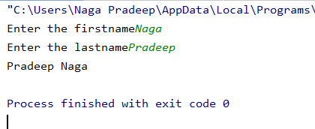

4.Write a Python program to find the volume of a sphere with diameter 12 cm.

Formula: V=4/3 * π * r 3

Ans.import math as m

r=12

V=4/3*m.pi*pow(r,3)

print(V)

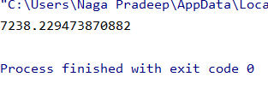

**Task 2:**

1. Write a program which accepts a sequence of comma-separated numbers from console and generate a list.

list=[]

Ans. for i in range(0,11):

list.append(i)

print(list)

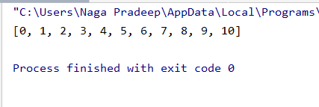

2. Create the below pattern using nested for loop in Python.

*

* *

* * *

* * * *

* * * * *

* * * *

* * *

* *

*

Ans: n=5  
for i in range(n):  
 for j in range(i):  
 print ('* ', end="")  
 print('')  
  
for i in range(n,0,-1):  
 for j in range(i):  
 print('* ', end="")  
 print(''

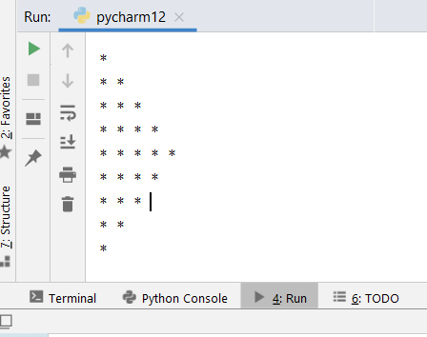

3. Write a Python program to reverse a word after accepting the input from the user.

Sample Output:

Input word: AcadGild

Output: dilGdacA

Ans. n=input("Enter the name")

print(n[-1::-1])

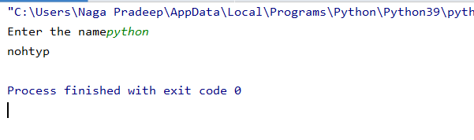

4. Write a Python Program to print the given string in the format specified in the ​sample output.

WE, THE PEOPLE OF INDIA, having solemnly resolved to constitute India into a SOVEREIGN, SOCIALIST, SECULAR, DEMOCRATIC REPUBLIC and to secure to all its citizens

Sample Output:

WE, THE PEOPLE OF INDIA, having solemnly resolved to constitute India into a SOVEREIGN, ! SOCIALIST, SECULAR, DEMOCRATIC REPUBLIC and to secure to all its citizens

Ans. print("WE, THE PEOPLE OF INDIA\n\thaving solemnly resolved to constitute India into a SOVEREIGN, !\n\t\tSOCIALIST, SECULAR, DEMOCRATIC REPUBLIC\n\t\t and to secure to all its citizens")

